# Ideation Phase

**Brainstorm & Idea Prioritization Template**

|  |  |
| --- | --- |
| Date | 19 September 2022 |
| Team ID | PNT2022TMID31914 |
| Project Name | Containment Zone Alerting Application |
| Maximum Marks | 4 Marks |

# Containment Zone Alert Application – Brainstorming & Idea Prioritization

Step-1:

Team Gathering, Collaboration and Selecting the Problem Statement Step-2:

Brainstorming, Idea Listing and Grouping Step-3:

Idea Prioritization

**IDEA:**

The app should have a user registration and login. After the user logged into the app it will track the user's location and update the database with the current location. If the user is visiting the containment zone he will get an alert notification.

They should login to the app and update the containment zones locations in the portal. Based on the location a Geofence will be created within a 100 meters radius. They should be able to see how many people are visiting that zone.

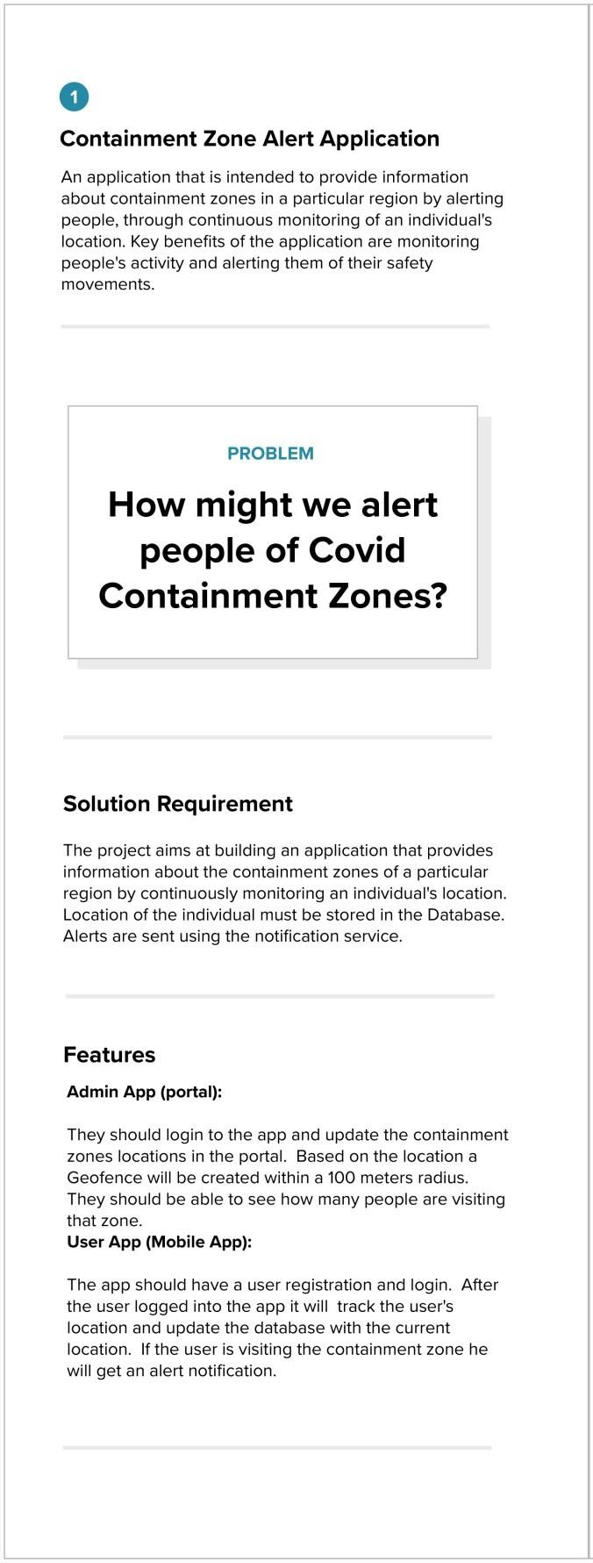

# Team Gathering, Collaboration and Selecting the Problem Statement

**Brainstorming, Idea Listing and Grouping**

FAVOURITE IDEAS

TEAM IDEA WORKSPACE

Containment Zone Tracking Application Development

GOAL

Fatheem Meeran S

For the precise use of location and get prior alert messages

Not too much colloborations

We need to access the location while to see the alerted zones

We might face lot of challenges

Maintain necessary data’s access necessary usage of location

CONSTRAINTS

Gnanasekaran K

How can we push the notification to the user

Karthikeyan S

If we want to push the notification we need to provide the alerted zones

Can we send the alert messages through App notification

Priyanka R

We can send grid type of alert messages

If the person encountered into the marked zones the alert messages are sent via mail

We must develop both web & mobile application for the various kinds of users

This application is intended to provide information about containment zones in a particular region by alerting people, through continuous monitoring of an individual’s location. Key benefits of the application are monitoring people’s activity and alerting them of their safety movements

COMMENTS

User can share their status as public whether they are affected or not

User must keep updated of their app for better reliable of data

For the affected person profile, user can contact the Emergency services

Make profit as public to alert nearby user whether they are affected or not?

User can contact the war room service for their Emergency purposes

There is a way to share your location to your saved contacts

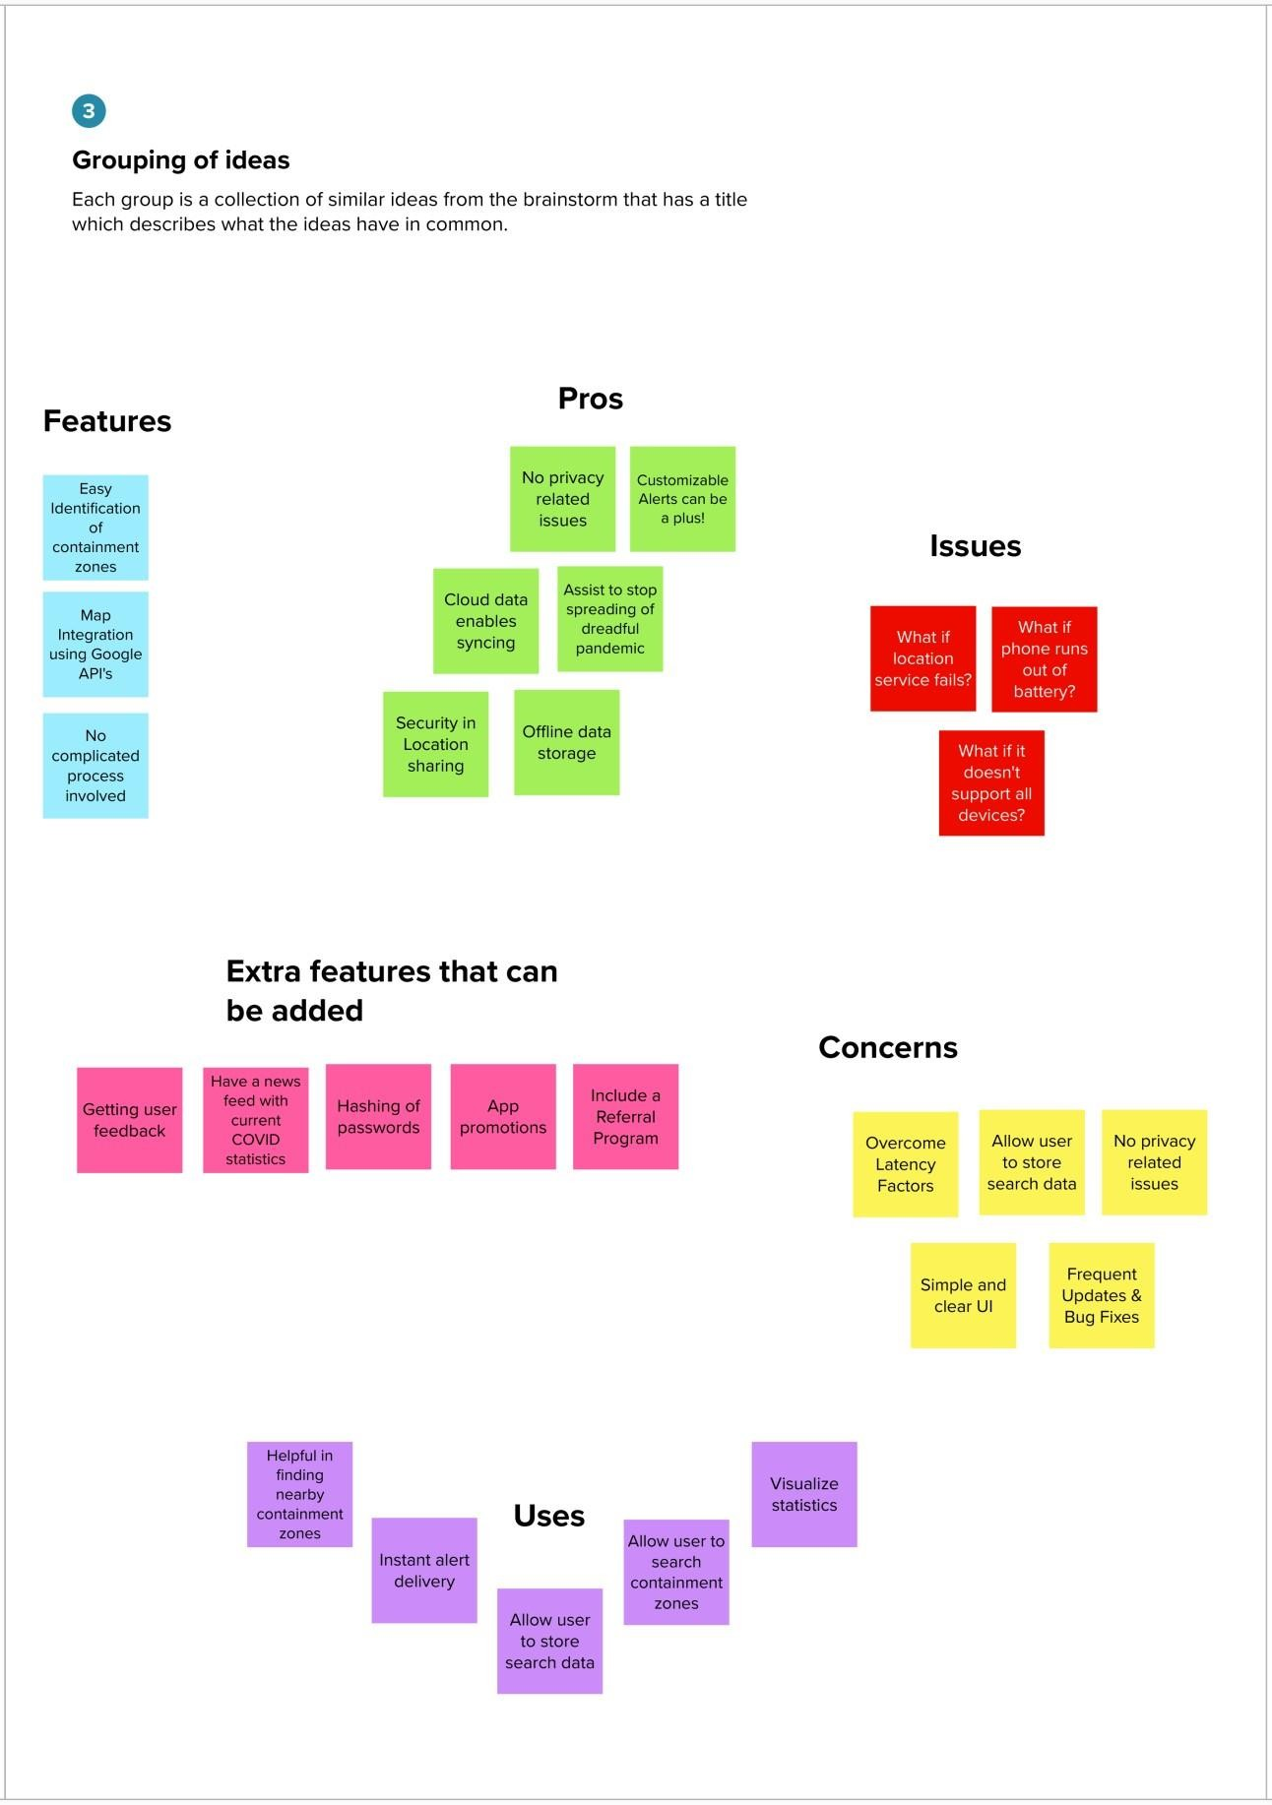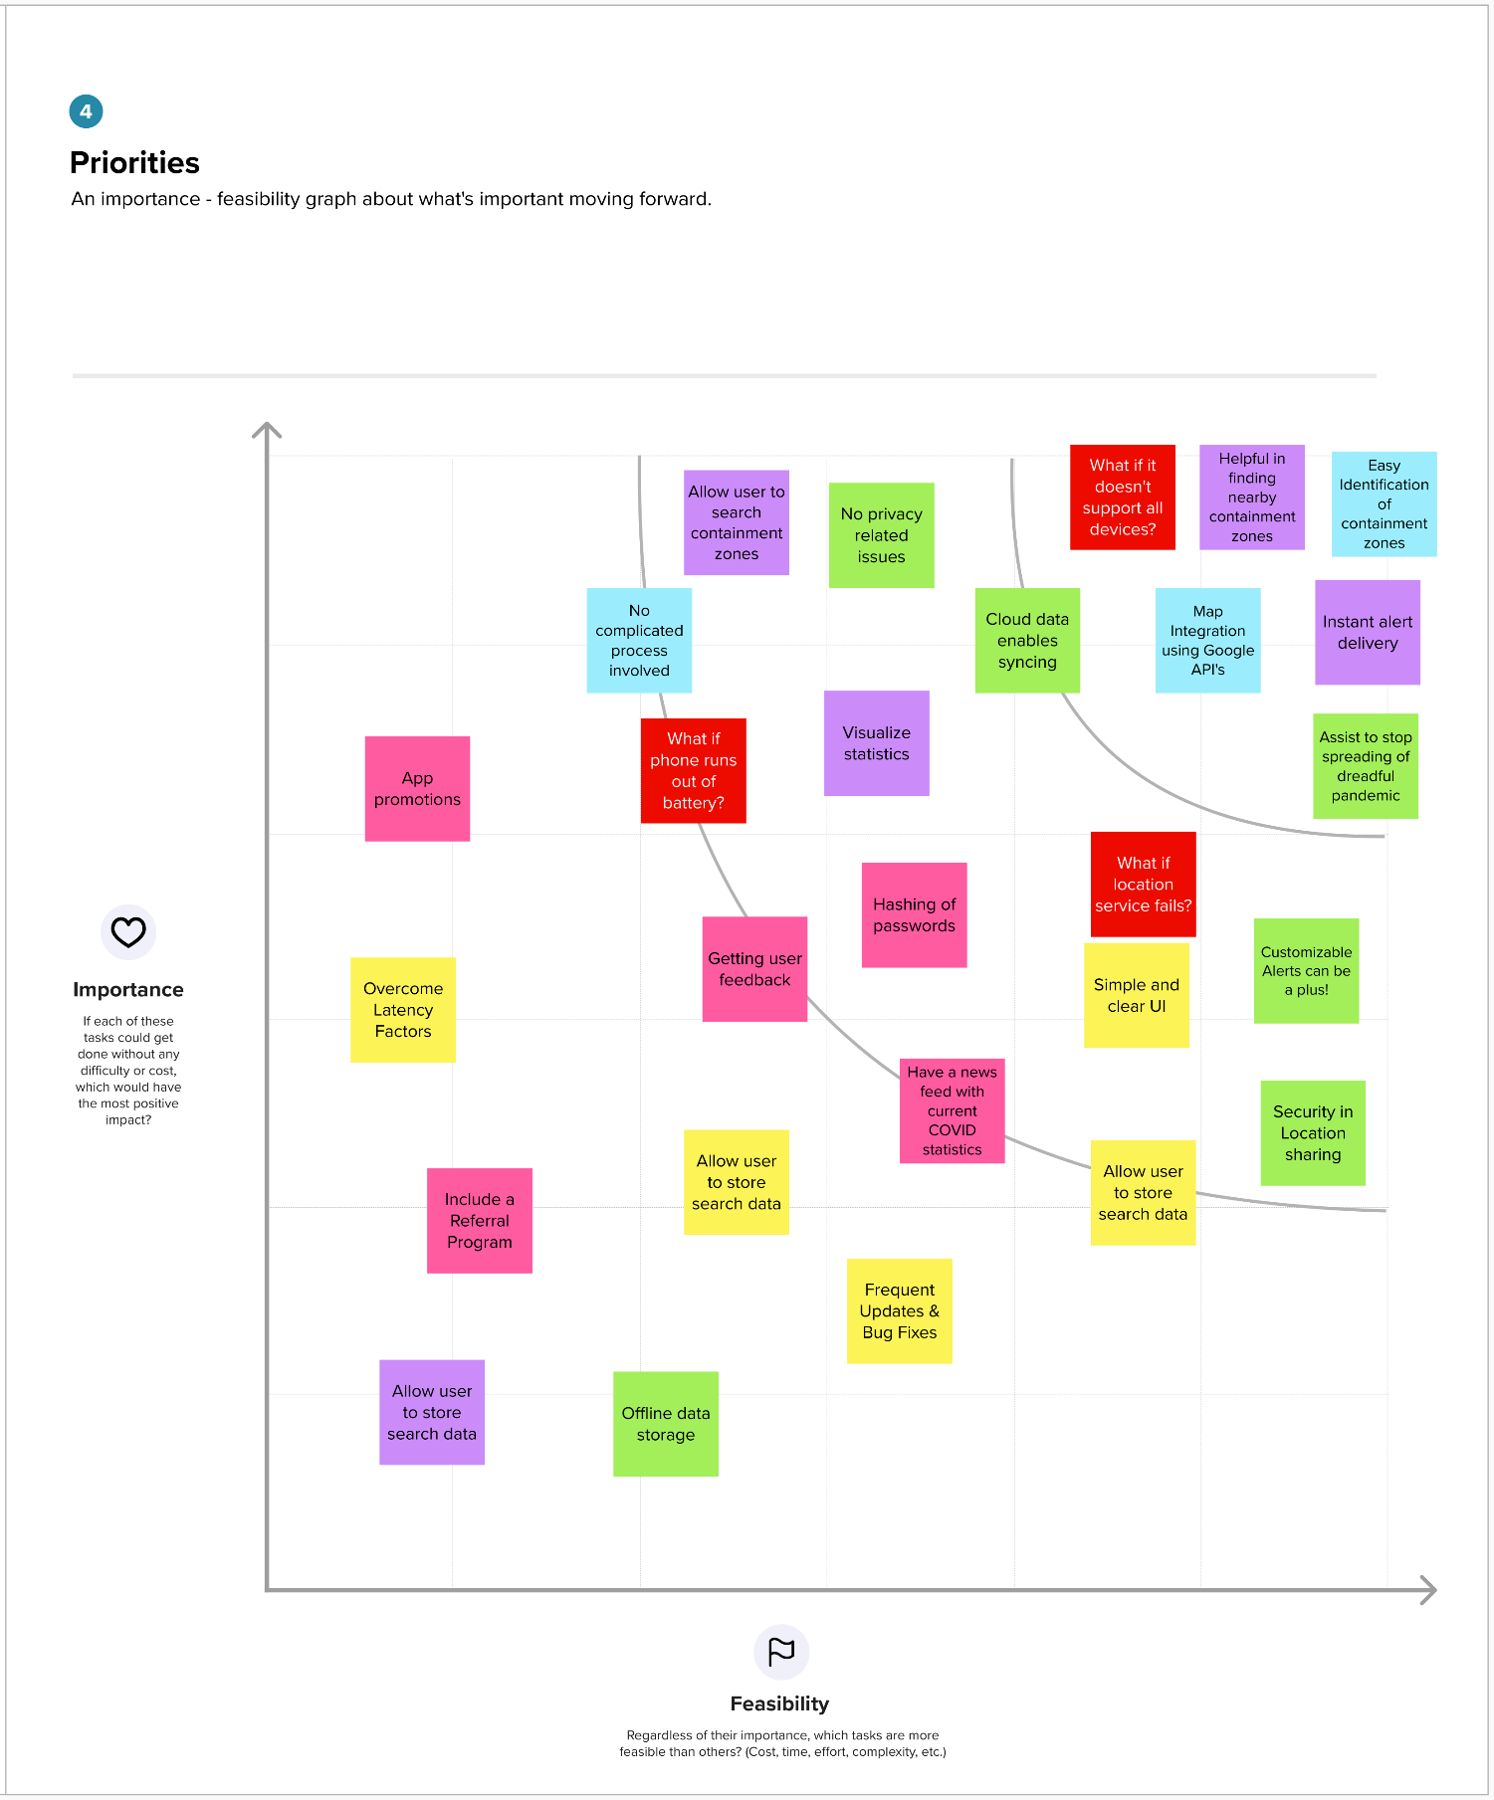

# Idea Prioritization